# Macintosh HD:Users:z018620:Dev:Helps:Icons:RapiTag:RapiTagAppIcon-01.pngTagIt – User Guide

Version 1.2

12/21/2016

## Introduction

TagIt is an application for encoding long range, UHF RFID EPC tags used in Target’s supply chain (PPC and backroom. Not sales floor). It works with proprietarily encoded EPC GIAIs that contain a T2ID (which is based on Target’s TCIN number, if available). The app takes input by scanning the RFID EPC tag, reading the barcodes on the products or printed RFID labels, or by direct user input, depending on the selected mode. Once all of the necessary information is available, the user then manually encodes (or the app automatically encodes) the RFID tag with the T2ID and a unique serial number (again, based on the selected mode). Upon success, a green check is displayed. If not, a red circle with a line through it is displayed.

## Requirements

An iOS device (iPod, iPhone, iPad) running iOS 9.x or higher (for Data Matrix barcodes)

A Zebra RFD8500 RFID reader.

The TagIt application via HockeyApp or direct install

Access to the T2 network for T2ID lookup via WiFi, or VPN

## Setup

Launch HockeyApp and download and install TagIt

Before launching TagIt, you must connect the Zebra reader. Use iOS Settings to connect via Bluetooth.

If you are using a Bluetooth reader, click on the settings button and configure Bluetooth as outlined in the next section.

## Bluetooth Setup

### On the RFID reader

Turn on the Bluetooth reader

Press and hold the Bluetooth pairing setup button until the blue light is flashing slowly (if you just turned it on, or installed a new battery, it may already be flashing)

### On the iOS device

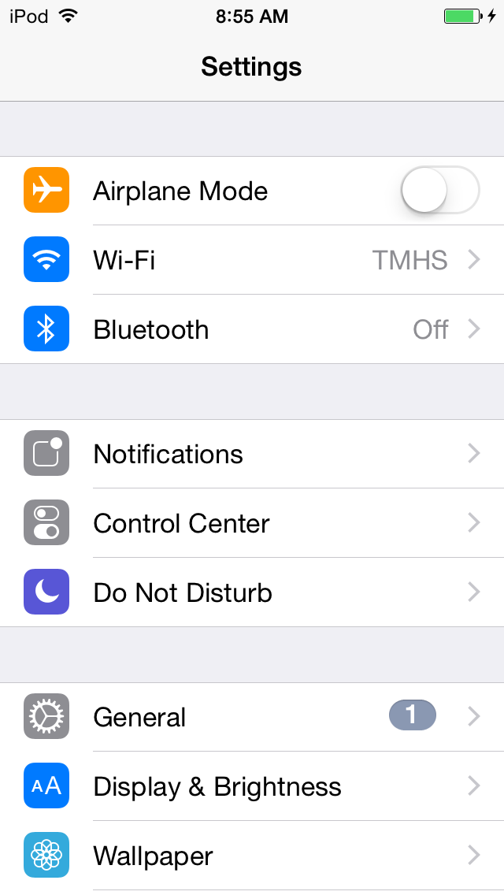Open Settings and click on Bluetooth:

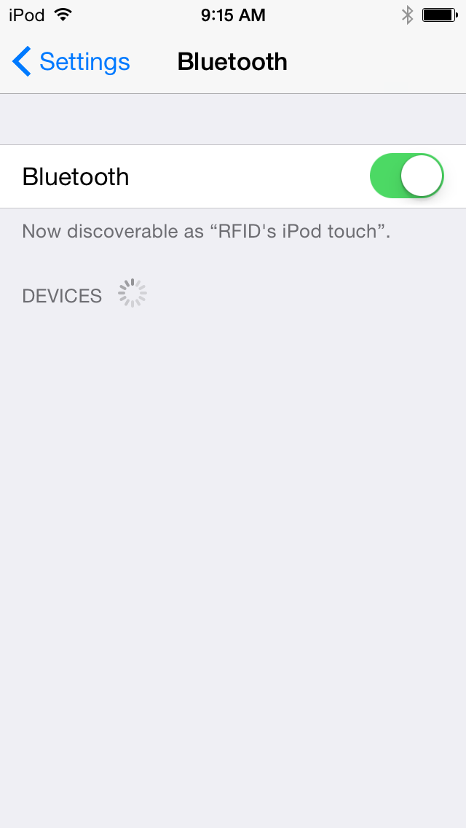Make sure Bluetooth is on:

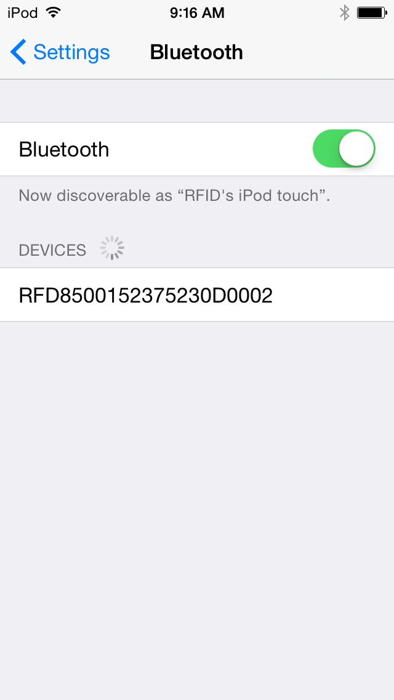

With the blue Bluetooth pairing light flashing on the RFID handheld, select the RFID device in the devices list:

### On the RFID reader

The Bluetooth pairing light will now begin flashing more quickly. Pull the trigger on the handheld to confirm pairing (this is a security feature – you must have physical possession of both devices to successfully pair them).

### Macintosh HD:Users:z018620:Pictures:iPhoto Library.photolibrary:Masters:2015:09:21:20150921-091654:IMG_0014.PNGOn the iOS device

The RFID device should now show as connected. If not, repeat the steps in this section until a successful connection is established:

You should now be paired, and can open the application.

## Launch TagIt

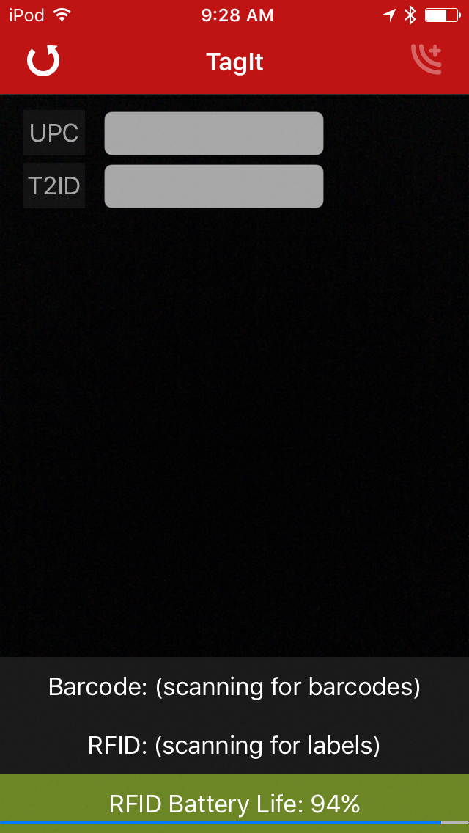If the reader was connected, you should see the RFID Battery Life displayed (see troubleshooting if not), and the RFID label should say “Scanning for labels” (see troubleshooting if not):

The reader starts in Scan Scan Encode mode by default. If you want to select a different mode, rotate the device sideways to see the other options:

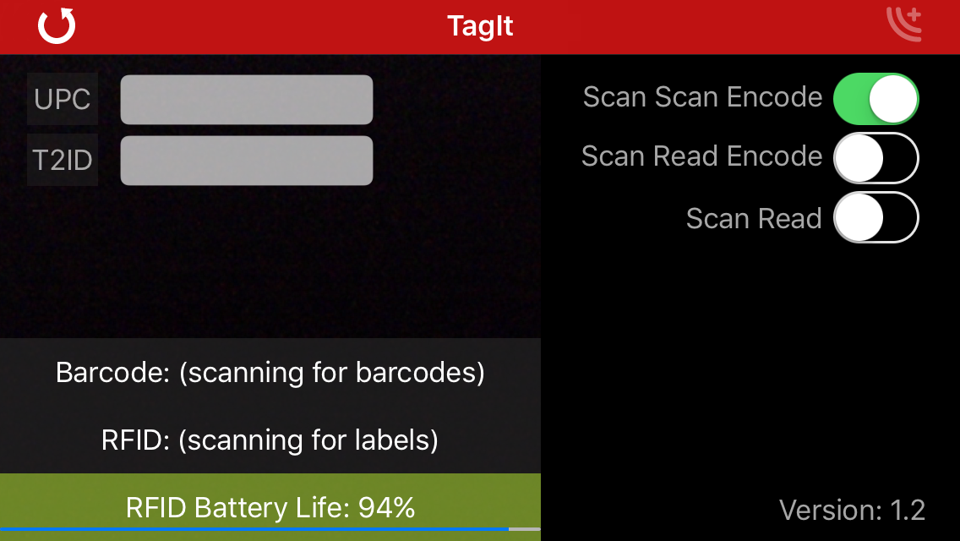

Select the desired option based on the descriptions below.

## Scan Scan Encode Mode

In this mode you scan the UPC barcode, scan the unique barcode or Data Matrix code printed on the RFID tag to be encoded, and as soon as both are read, the app automatically encodes the tag, eliminating your need to interact with the app. You can scan the barcodes in any order. Use this mode if you have a lot of RFID tags in the close proximity or adjacent on a roll and you want to explicitly direct the RFID reader to ONLY encode the tag whose barcode was read.

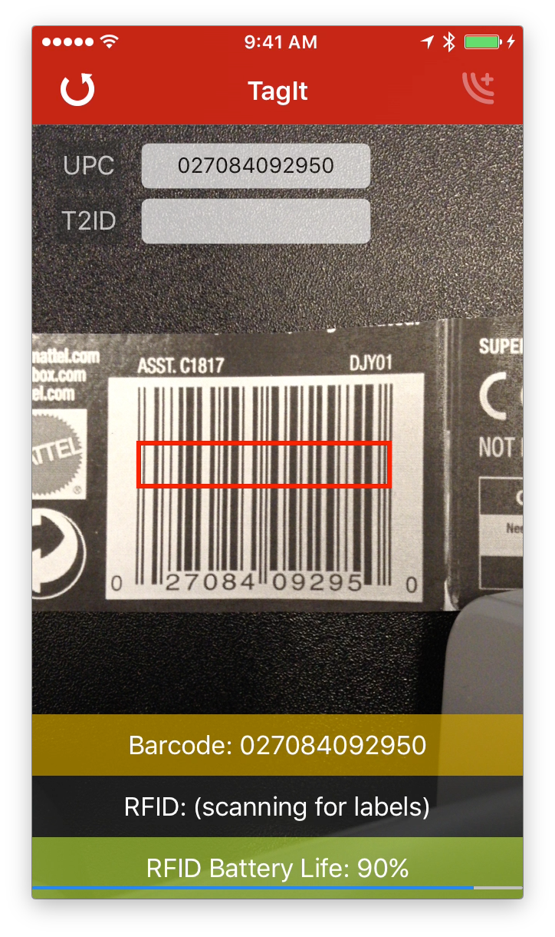Begin by scanning the UPC of a product to encode with the iOS device by centering the barcode anywhere in the field of view of the camera. Once scanned, the Barcode is displayed in yellow while the T2ID is being looked up:

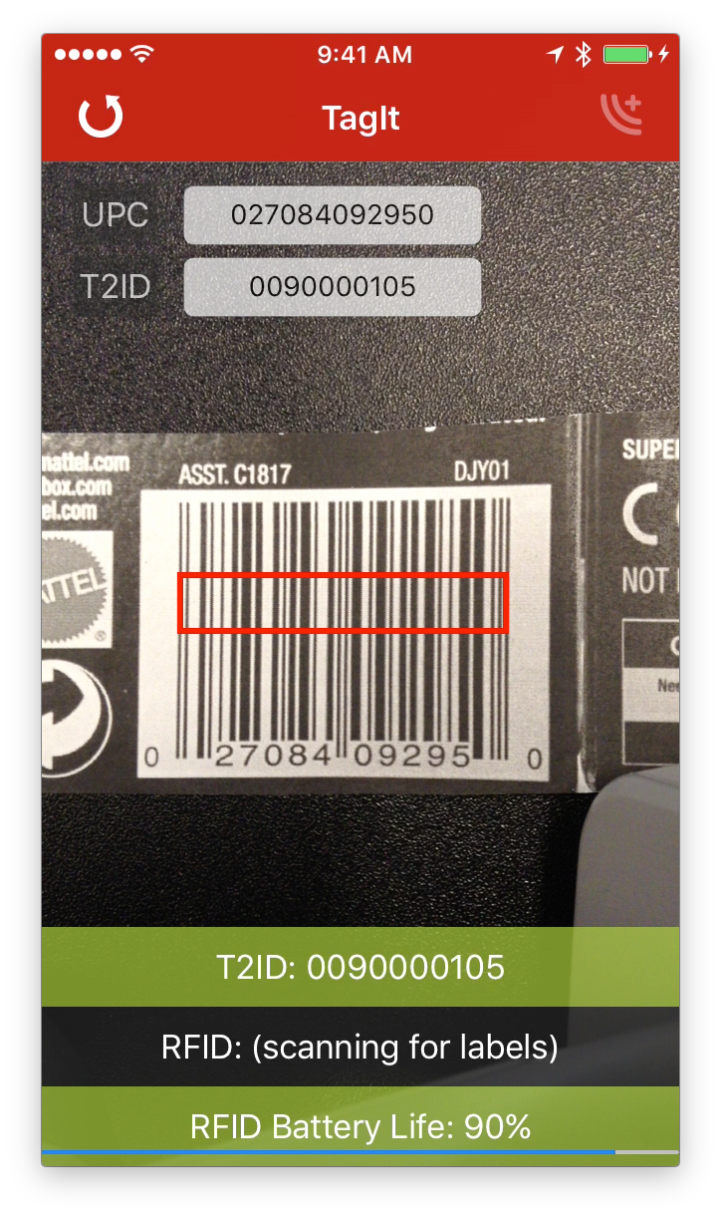

Once scanned the T2ID is looked up and automatically displayed:

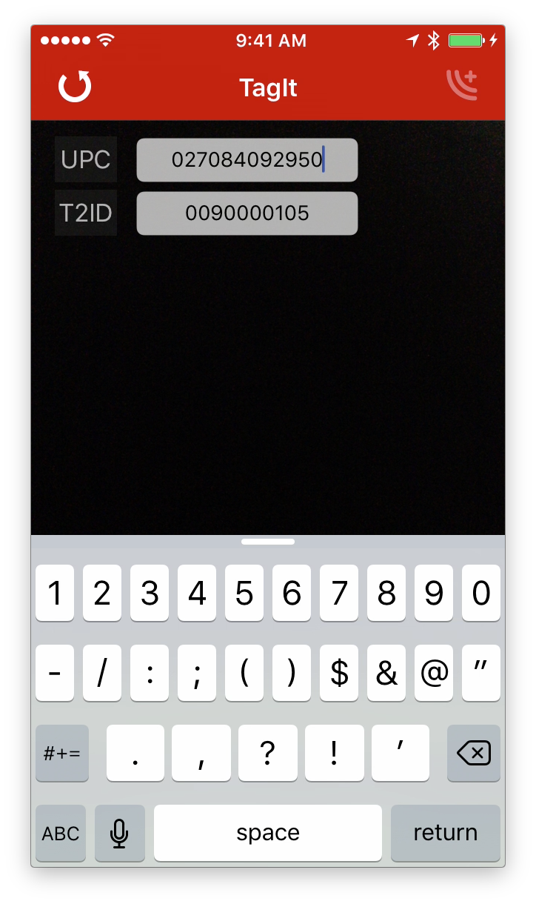Note: you can also manually enter either the UPC or the T2ID in the appropriate text fields. You must hit return to accept any manual entries. If you enter a UPC, the T2ID is automatically looked up:

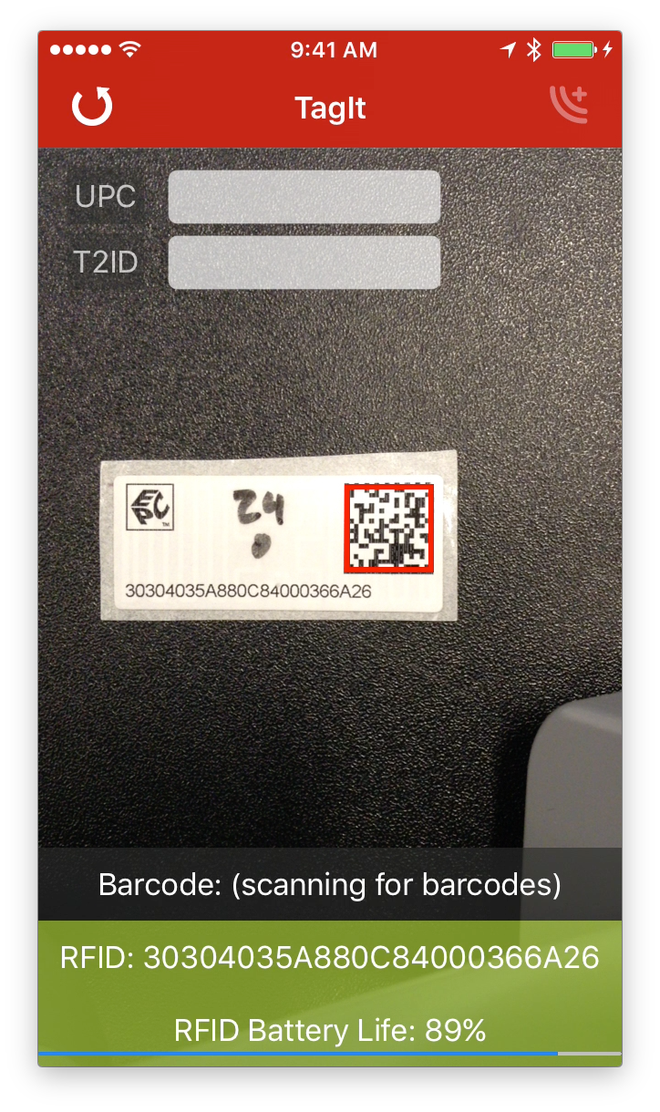

Now scan the data matrix or barcode on the RFID tag to be encoded:

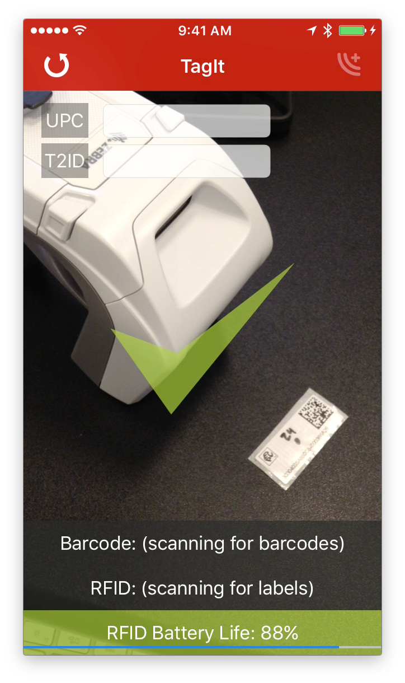After scanning the RFID tag’s barcode, make sure you hold the tag 2 to 5 inches away from the reader (set or hold it in front of the reader while reading the barcode for best results):

Note that the T2ID field is auto populated, and a unique serial number generated, and the tag is automatically encoded. If successful, all fields are cleared and you see a green check:

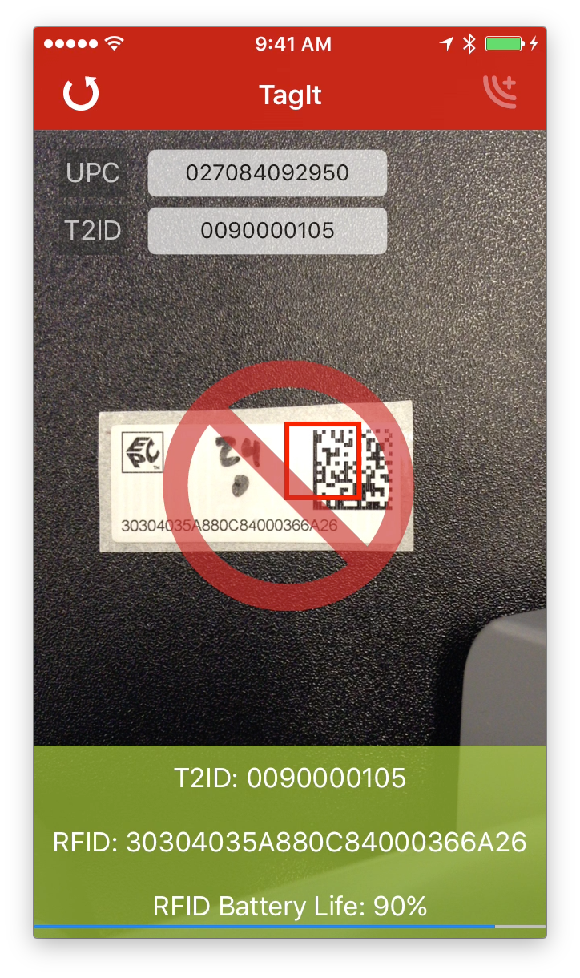

If it failed, the fields are not cleared, and you see a red circle with a slash:

In this mode, if the tag encode fails, it might have partially written the tag, and if that is the case, you won’t be able to scan the label on the tag to encode it (the numbers no longer match!). Try the Scan Read Encode method outlined in the next section.

## Scan Read Encode

In this mode you scan the UPC barcode and read the RFID tag to be encoded with the reader (much faster). As with Scan Scan Encode, as soon as both are read, the app automatically encodes the tag, eliminating your need to interact with the app. You can scan the barcode and RFID tag in any order. This will encode the first RFID tag read, so to make sure that you are encoding the right tag, you need to isolate it and the reader from any other tags, otherwise you won’t be sure which tag was encoded. The reader is configured to only read tags in close proximity to the reader, so tags about an arm’s length away should be out of range.

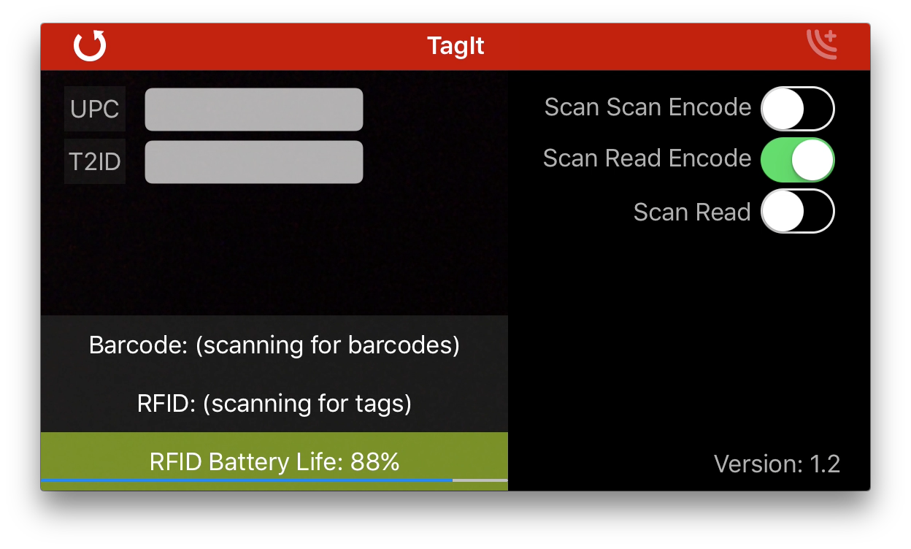

This mode works just like Scan Scan Encode, and the tag will be encoded as soon as all the information is available. A big benefit of this mode is if you have more than one item with the same UPC to encode, you can simply hold a new RFID tag in front of the reader, and it will continue encoding new tags with unique serial numbers for that T2ID until a new barcode is read. This expedites tagging an entire box of the same item.

## Scan Read

Scan Read is the manual version of Scan Read Encode, but in this mode you have to press the “encode” button in the upper right to manually trigger the encode step. This button is only active when all the requisite information is available.

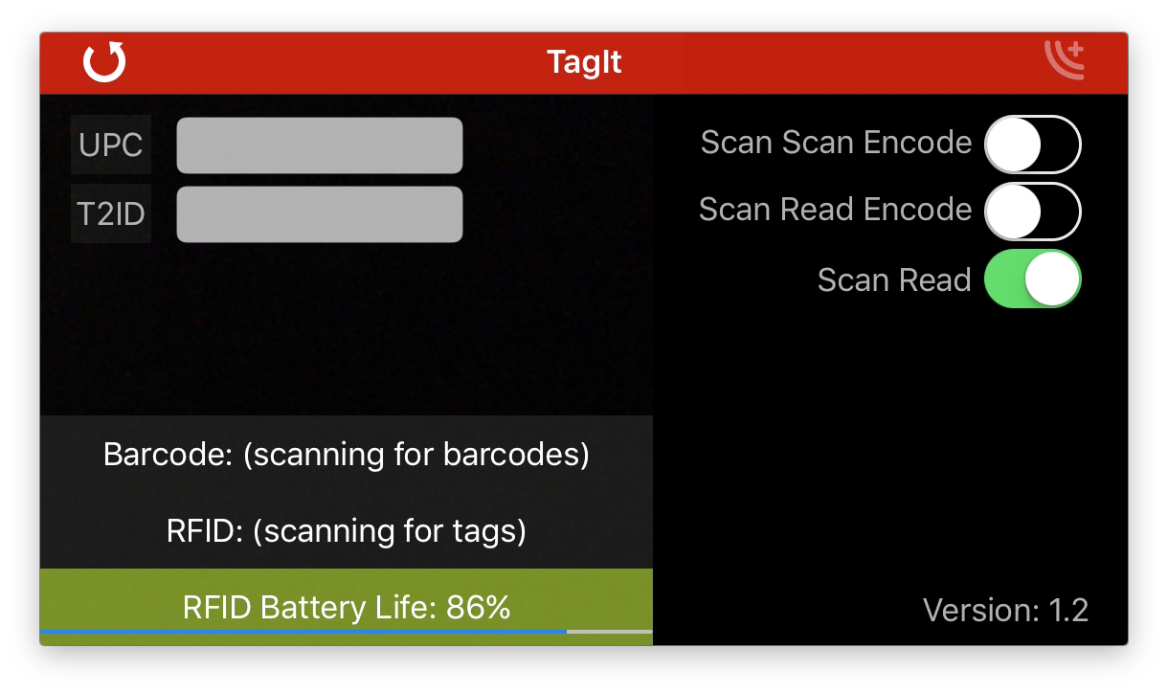

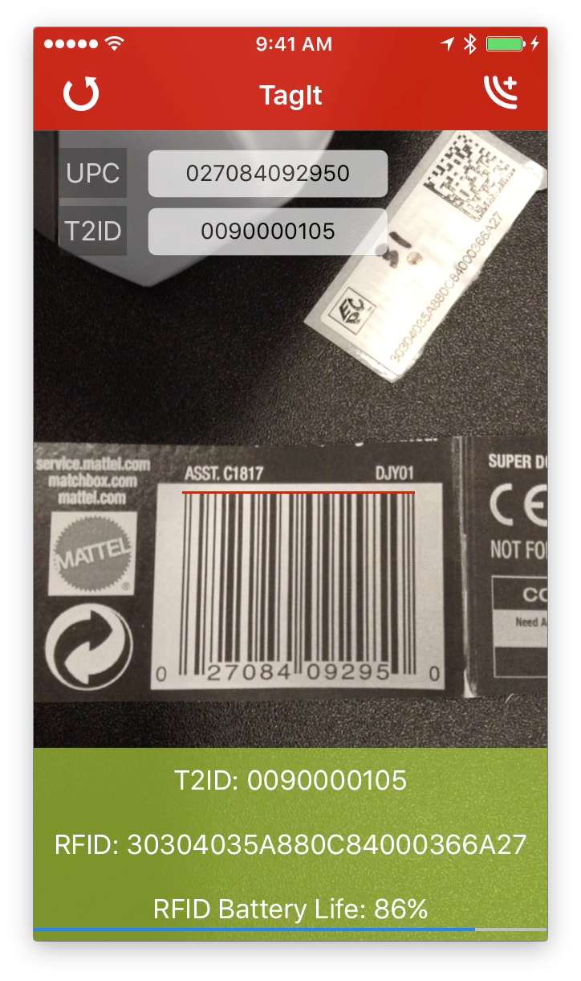As with Scan Read Encode, in this mode, the reader tries to read the actual RFID tag to be encoded, so make sure you are only holding one within range. (Note: If you can’t read the RFID tag, you can still scan the printed barcode on the RFID label as well, but if you can’t read the tag, you probably won’t be able to encode it either). Now scan the UPC barcode on the product to be tagged or enter the information manually:

And you now see all the information is ready (T2ID and RFID fields complete and green).

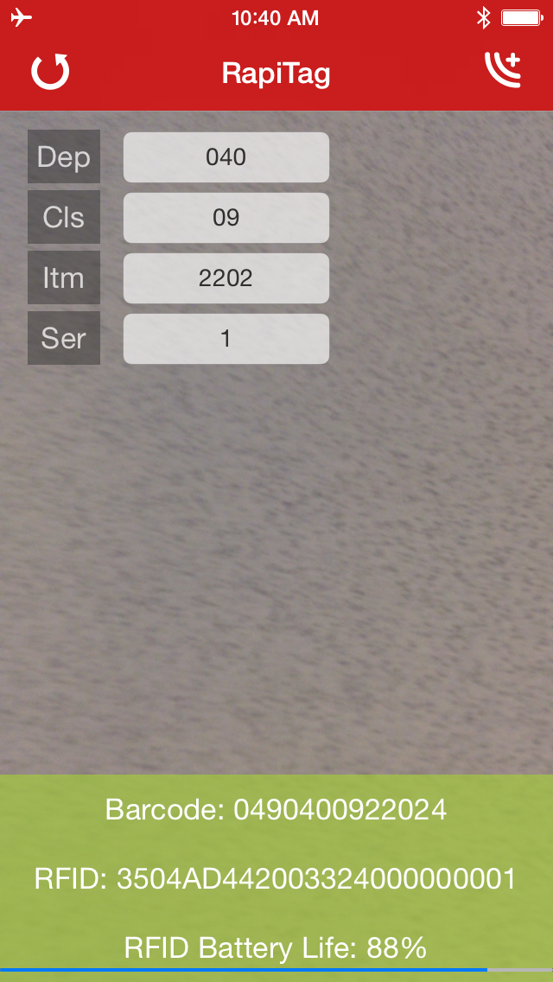Once all the proper input has been collected, the Encode button in the upper right is enabled:

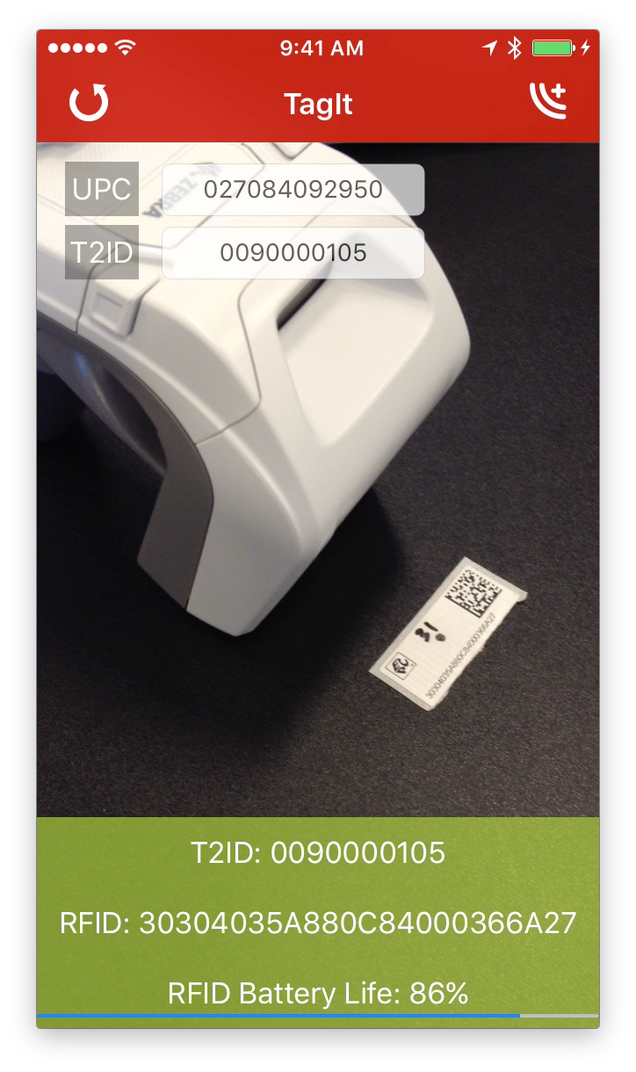

Keeping the EPC tag in range (2 to 5 inches), press the encode button and TagIt will attempt to encode the tag.:

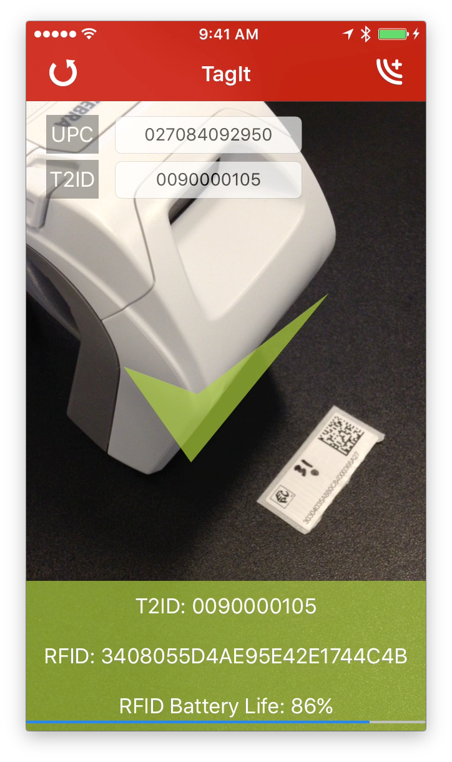

If successful, a green check mark is displayed and the T2ID and RFID fields will be green:

If it fails, then a red circle with a line through it will be displayed, and the Barcode and RFID fields will be red.

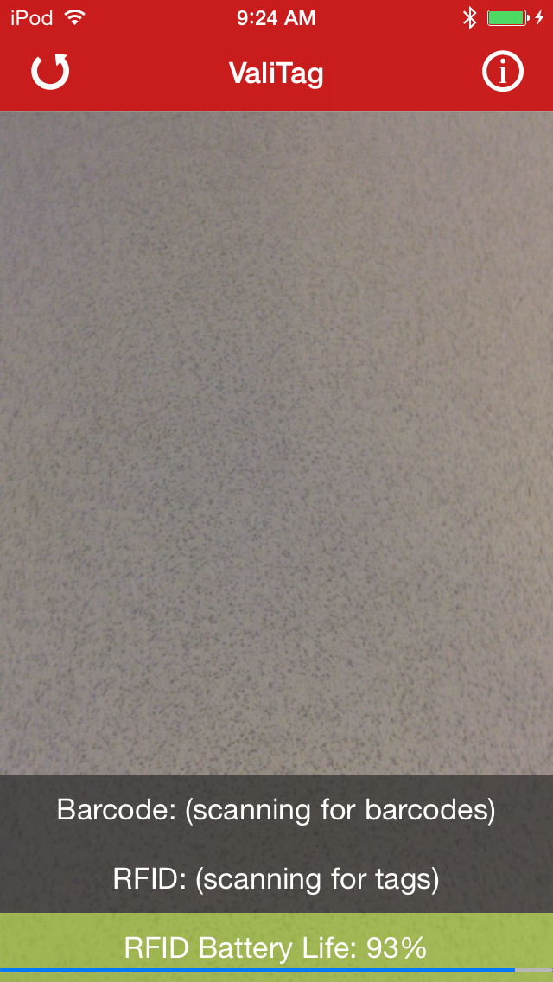To reattempt the tag encoding, or to read another UPC, or to simply start over in manual encode mode, press the reset button on the upper left:

Important note: the power settings on the RFID reader have been turned down enough so that only tags within the immediate range of the reader will be read and encoded. You should be able to keep tags at arm’s reach away on either side and they won’t be affected, but occasionally they are. You may need to test this in your environment until you are sure you are reading and encoding only the RFID tag that is in range. To keep the application simple, these settings are not configurable.

## Scanned Product

After the UPC barcode scanned or the T2ID entered, the item is looked up, and if found, a description and product image are displayed when the app is in landscape mode:

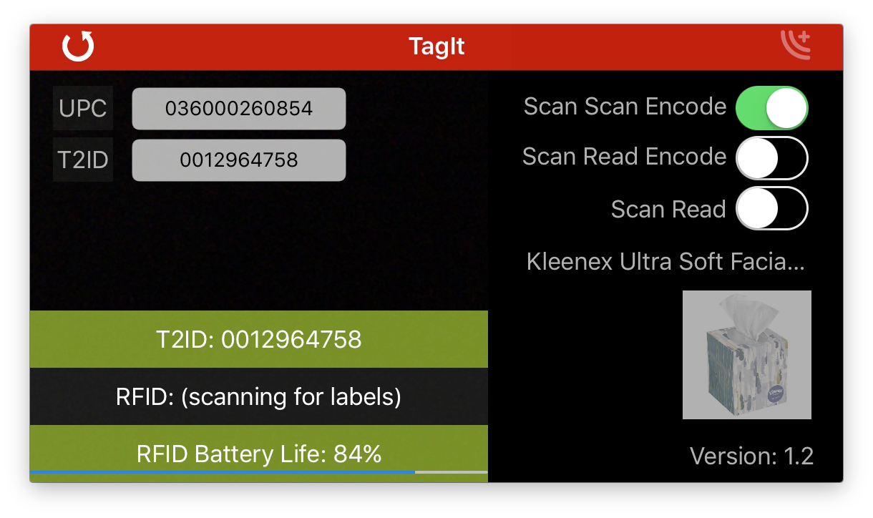

This is useful as a quick check should you have any question that the right product has been scanned.

Important NOTE: If there is no item configured in Target’s Item system, the T2 system will generate a placeholder T2ID with the following information:

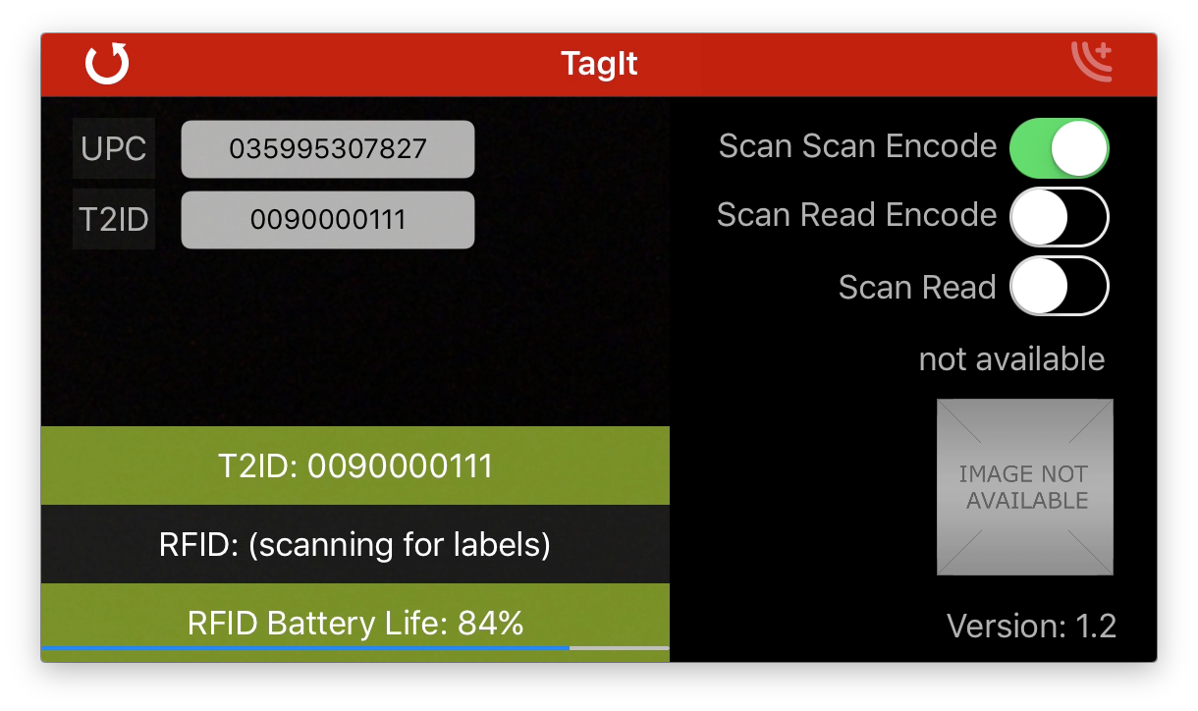

This is by design, and you can safely proceed

## Product Selection

The vast majority of items to be tagged will only have one T2ID for the UPC barcode. There are some categories, however, where there are multiple T2IDs assigned to the same UPC barcode (e.g. Kleenex or Matchbox cars, all the unique assortments share the same UPC barcode).

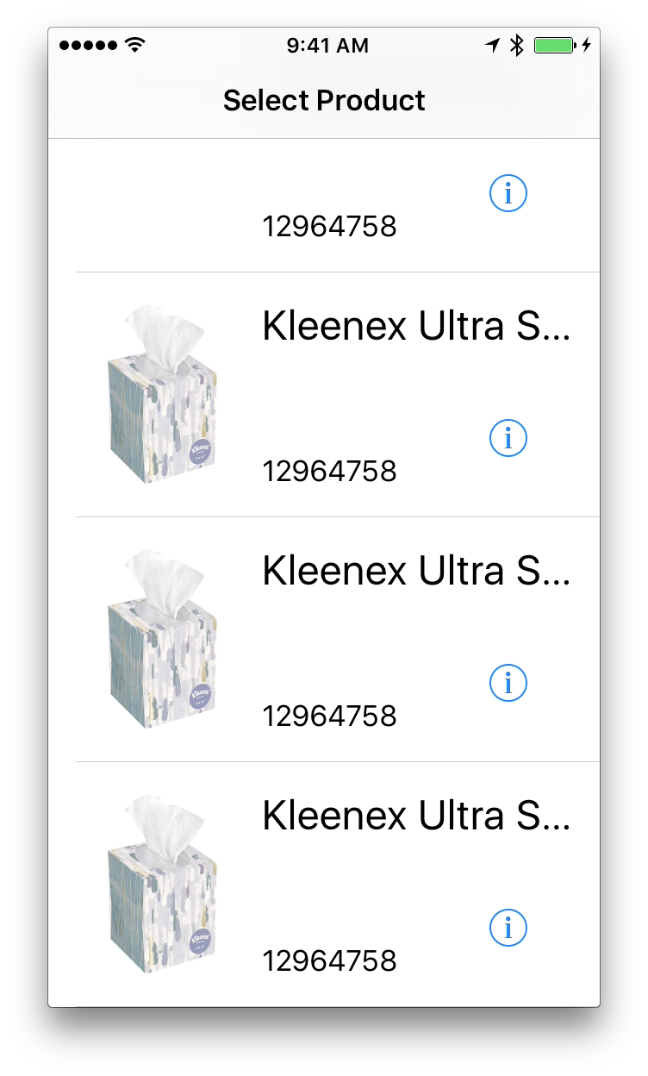

If the scanned barcode is associated with more than one T2ID, then a dialog is presented with all the possible items:

When this dialog appears, you can scroll through the items and pick the correct one (Note: the example to the left is canned, and all the items have identical images. For some product categories, the individual T2IDs would have distinct images to aid in the selection process.)

Pick the item by clicking anywhere but on the information button “i”.

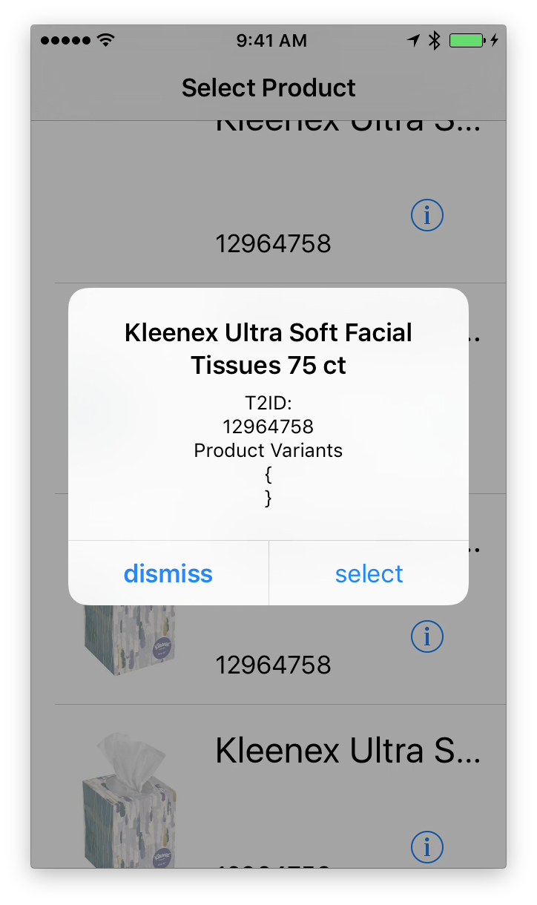If you want more information before selecting, click on the information button (“i”) to the right of the item and all of the details will be presented:

If this is the item you want, choose “select”, and all of the selection dialogs will be dismissed.

If this is NOT the item you want, choose “dismiss” and you will be returned to the product selection screen to choose another.

NOTE: in this example, the Product Variants field is empty. For other products, this field will contain information like style, color, size etc. to aid in the selection of the right item.

## Basic Troubleshooting

* **No Battery life displayed**
  + This can be an indication that the reader is not properly connected, but not all readers report their battery life in the same manner, so it is not a guarantee.
  + Check the reader connections (iOS Bluetooth settings)
* **Connecting to reader message**
  + If this message is displayed, press the reset button in the upper left and try again.
  + If after a couple of resets it still won’t connect
    - If you are using a Bluetooth reader, proceed to the next step
* **Bluetooth connection fails**
  + Exit TagIt
  + Go into iOS Settings, Bluetooth and click on the ‘i’ button to the right of the RFID reader
  + Select “Forget this Device” and accept

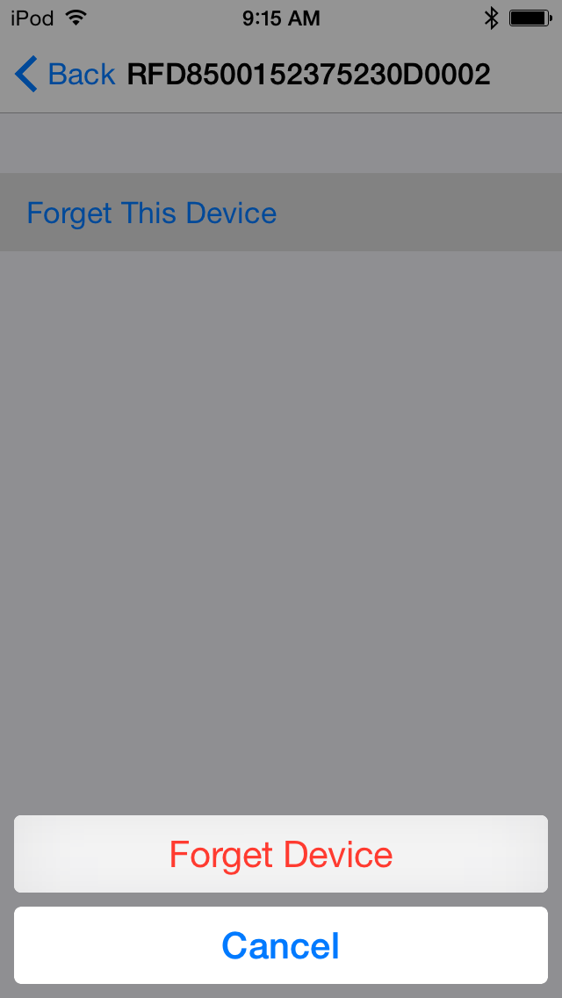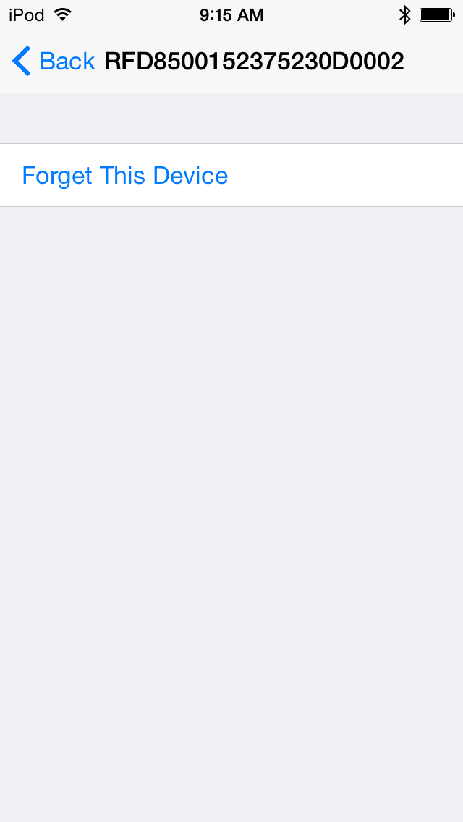

* + Once forgotten, go through the setup steps outlined in “Bluetooth Setup” to reconnect the reader.
  + Wait until it is connected and then relaunch TagIt.
  + The reader should connect automatically.